**LAB#05**

Point out Errors in Point.cpp

***ERROR#01***



***Compiler Message***

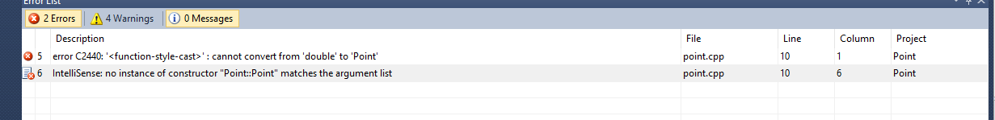

***ERROR#02***

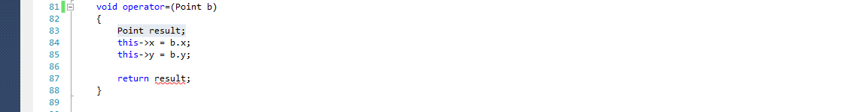

***Compiler Message***

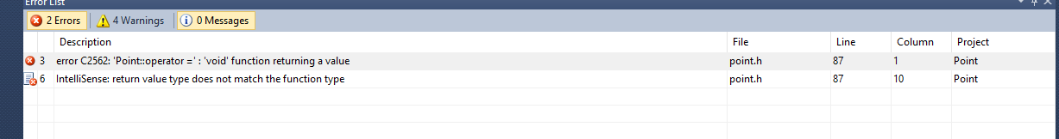

***ERROR#03***

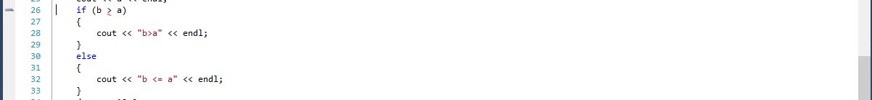

***Compiler Message***



***ERROR#04***



Confusion

Do not overload + operator whose second argument is float but my program will run successfully. WHY????

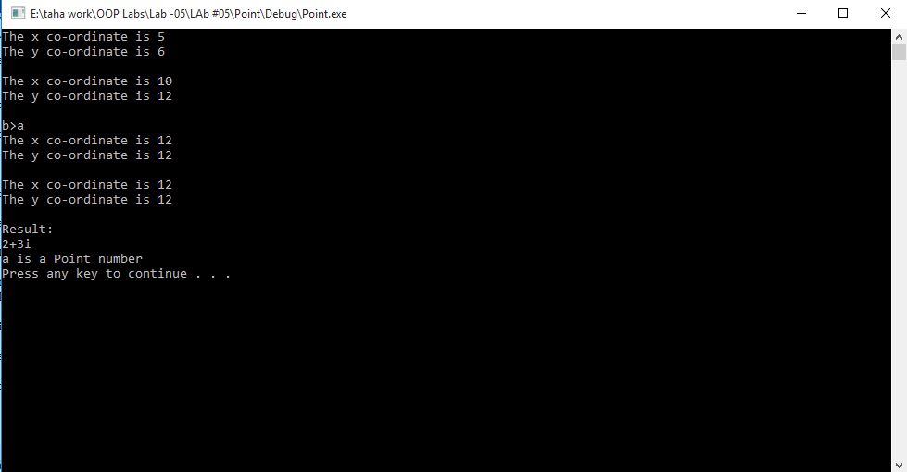

***ERROR#05***



***Compiler Message***



***ERROR#06***

Confusion

Type mis-match Error do not come. And Program runs successfully.



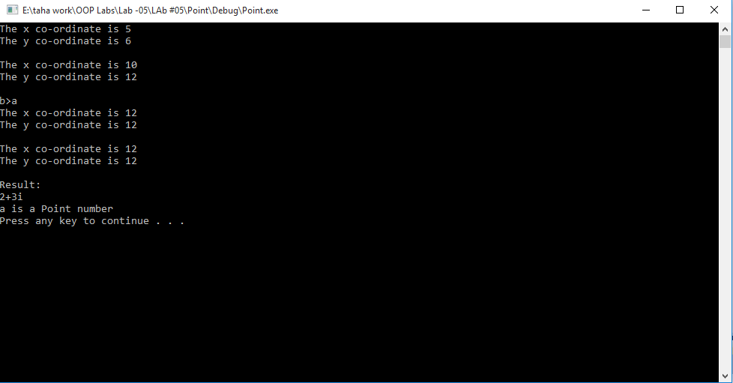

***ERROR#07***

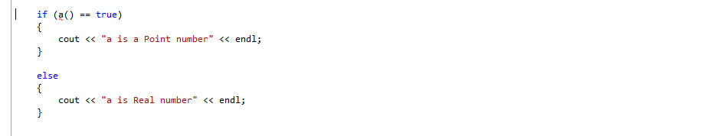

***Compiler Message***

